
PUCIT
Punjab University College of Information Technology

Second Deliverable
Version 1.0

School Management System

Session: BS SE Fall 2019
Project Supervisor: Sir Umair Babar

Submitted By
BSEF19A518- Atif Aqeel
BSEF19A537-Moeez Hayder
BSEF19M507– Shahwar Munir
BSEF19M508 – Muhammad Ahsan

Punjab University College of Information Technology
University of the Punjab, Lahore.

Introduction
Second deliverable is all about the use-case modeling and software design. In the previous deliverable, analysis of the system is completed. So, we understand the current situation of the problem domain. Now we are ready to strive for a solution for the problem domain. Following artifacts must be included in this deliverable.

- Use case description
- Use case diagram refined
- Domain Model
- Collaboration Diagram
- Operation Contracts
- Design Class Diagram

- UC-Register User:
Use Case Description:
It allows a user admin to sign-up for this website. It will require user to fill a form and his name, email and password.
Pre-Condition:
- Website is running properly with no failure.
- A user must have a valid email address.

Basic Flow:
- User admin will click Sign Up button and will be redirected to Sign Up Page.
- User admin will enter Institute name.
- User admin will enter his/her e-mail.
- User admin will enter his/her First and Last Name.
- Use admin will enter password of his/her choice.
- User admin will re-enter the password.
- User admin will press the submit button.

Alternate Flows:

Alternative Flow 1:
If password is weak or less than required minimum length then an error message is displayed showing “Password is weak”.
Alternative Flow 2:
If user enters some different password as compared to previous password then a message prompt is shown indicating “Password doesn’t match”.
Alternative Flow 3:
If user enters an invalid email, then a pop up will be shown with a message “Invalid Email Address”.
Post Condition:
User will be redirected to the home page and will be signed-in. Database will be updated.

- UC-Log_In

Use Case Description:
It allows a user to Log In to this website. It will require user to enter his email and password.
Pre-Condition:
- Website is running properly with no failure.
- A user must have valid credentials.

Basic Flow:
- User will enter email address.
- User will enter password.
- User will press Log-In button.

Alternate Flows:

Alternative Flow 1:
3a. If user enters an incorrect email or password then a pop-up message is shown “Incorrect
E-mail or Password”.

Post Condition:
That user will be logged in and will be redirected to the same page from where he clicked the Log-In option.

- UC_Edit_Profile (As User Admin)

Use Case Description:
It will allow the user admin to manage (editing and updating) of his/her/other user’s profile.
Process:
Pre-Condition:
- Website is running properly with no failure.
- A user admin must have Logged In to the website.
- User (Staff, Teacher or Student) account must exist.
Basic Flow:
- User Admin will search the particular person whose data is required to be edited.
- User admin will click Edit profile button on his/her or particular user’s profile in which changing is required and will be redirected to that profile.
- User admin will edit the particular data where editing is required.
- User admin will click Update profile button to update the editing that he/she made in profile.

Alternate Flows:

Alternative Flow 1:
1a. Unexpected System Failure.
1b. If user does not exist then a message will appear, “profile not found”.

Post Condition:
A pop-up will be shown that “Profile updated successfully” and redirect to that profile page so that user admin can view or edit it again if there’s any confusion.

- UC_Edit_Profile (As Main Admin)
Use Case Description:
It will allow the main admin to manage (editing and updating) of his/her/other user admin/s.
Process:
Pre-Condition:
- Website is running properly with no failure.
- A main admin must have Logged In to the website.
- User admin account must exists.
Basic Flow:
- Main Admin will search the particular user admin whose data is required to be edited.
- Main admin will click Edit profile button on his/her or particular user admin’s profile in which changing is required and will be redirected to that profile.
- Main admin will edit the particular data where editing is required.
- Main admin will click Update profile button to update the editing that he/she made in profile.

Alternate Flows:
Alternative Flow 1:
1a. Unexpected System Failure.
1b. If user admin does not exist then a message will appear, “profile not found”.

Post Condition:
A pop-up will be shown that “Profile updated successfully” and redirect to that profile page so that main admin can view or edit it again if there’s any confusion.

- UC_Delete_Account:

Use Case Description:
It will allow a user admin to delete account of any user.
Pre-Condition:
- Website is running properly with no failure.
- A user admin must have Logged In to the website.
- The account of user that has to be deleted must exist.

Basic Flow:
- User admin will search the particular account that has to be deleted.
- User admin will click on Delete Account button in order to proceed deletion.
- User Admin will choose “yes” button that will be appeared after clicking Delete Account button that “are you sure to delete the account?”.

Alternate Flows:

Alternative Flow 1:
1a. Unexpected System Failure or error.
1b. If user does not exist then a message will appear, “profile not found”.

Alternative Flow 2:
3a. If user admin click “No” button, then it will be redirected to the previous page.

Post Condition:
A pop up will be shown that “Account Deleted Successfully”.

- UC_Delete_Admin_Account:

Use Case Description:
It will allow a main admin to delete account of any user admin.
Pre-Condition:
- Website is running properly with no failure.
- A main admin must have Logged In to the website.
- The account of user admin that has to be deleted must exist.

Basic Flow:
- Main admin will search the particular account that has to be deleted.
- Main admin will click on Delete Account button in order to proceed deletion.
- Main admin will choose “yes” button that will be appeared after clicking Delete Account button that “are you sure to delete the account?”.

Alternate Flows:

Alternative Flow 1:
1a. Unexpected System Failure or error.
1b. If user does not exist then a message will appear, “profile not found”.

Alternative Flow 2:
3a. If user admin click “No” button, then it will be redirected to the previous page.

Post Condition:
A pop up will be shown that “Account Deleted Successfully”.

- UC_Give_Privilege:

Use Case Description:
It will allow a user admin to give privilege to the clerk account.
Pre-Condition:
- Website is running properly with no failure.
- A user admin must have Logged In to the website.

Basic Flow:
- User admin will select the Privileges from the check box menu while creating or editing the account of a clerk.
- User admin will click the Assign Privileges button.

Alternate Flows:

Alternative Flow 1:
1a. Unexpected System Failure or error.

Post Condition:
The new clerk account will be able to use these particular Privileges that the user admin assigned him.
- UC_Feedback:

Use Case Description:
It will allow the all users to give feedback about our product (SMS).
Pre-Condition:
- Website is running properly with no failure.
- A user must have Logged In to the website.

Basic Flow:
- User will press Give Feedback Button from menu.
- User will be able to view recent feedbacks.

Alternate Flows:
Alternative Flow 1:
1a. Unexpected System Failure or error.

Post Condition:
A pop up will be shown that “your feedback is submitted successfully”.

- UC_Log_Out:

Use Case Description:
It will allow all users to logout their account.
Pre-Condition:
- Website is running properly with no failure.
- A user must have Logged In to the website.

Basic Flow:
- User will click Logout Button from the navigation bar.
- A pop-up message will be appeared “Are you sure, You want to log out.”
- If user press “yes” then will be logged out.

Alternate Flows:

Alternative Flow 1:
1a. Unexpected System Failure or error.
Alternative Flow 2:
3a. User may press the “No” button in the pop Up and hence will be redirected to the previous page

Post Condition:
User will be redirected to the login Page.

- UC_View_Profile:

Use Case Description:
It will allow a user to view Profile.
Pre-Condition:
- Website is running properly with no failure.
- User must have Logged In to the website.

Basic Flow:
- User will click the Profile button on the navigation bar.
- User will click view Profile Option.

Alternate Flows:

Alternative Flow 1:
1a. Unexpected System Failure or error.

Post Condition:
User will be redirected to the Profile page where he can see his complete profile details.

Use case Diagram (refined and updated)

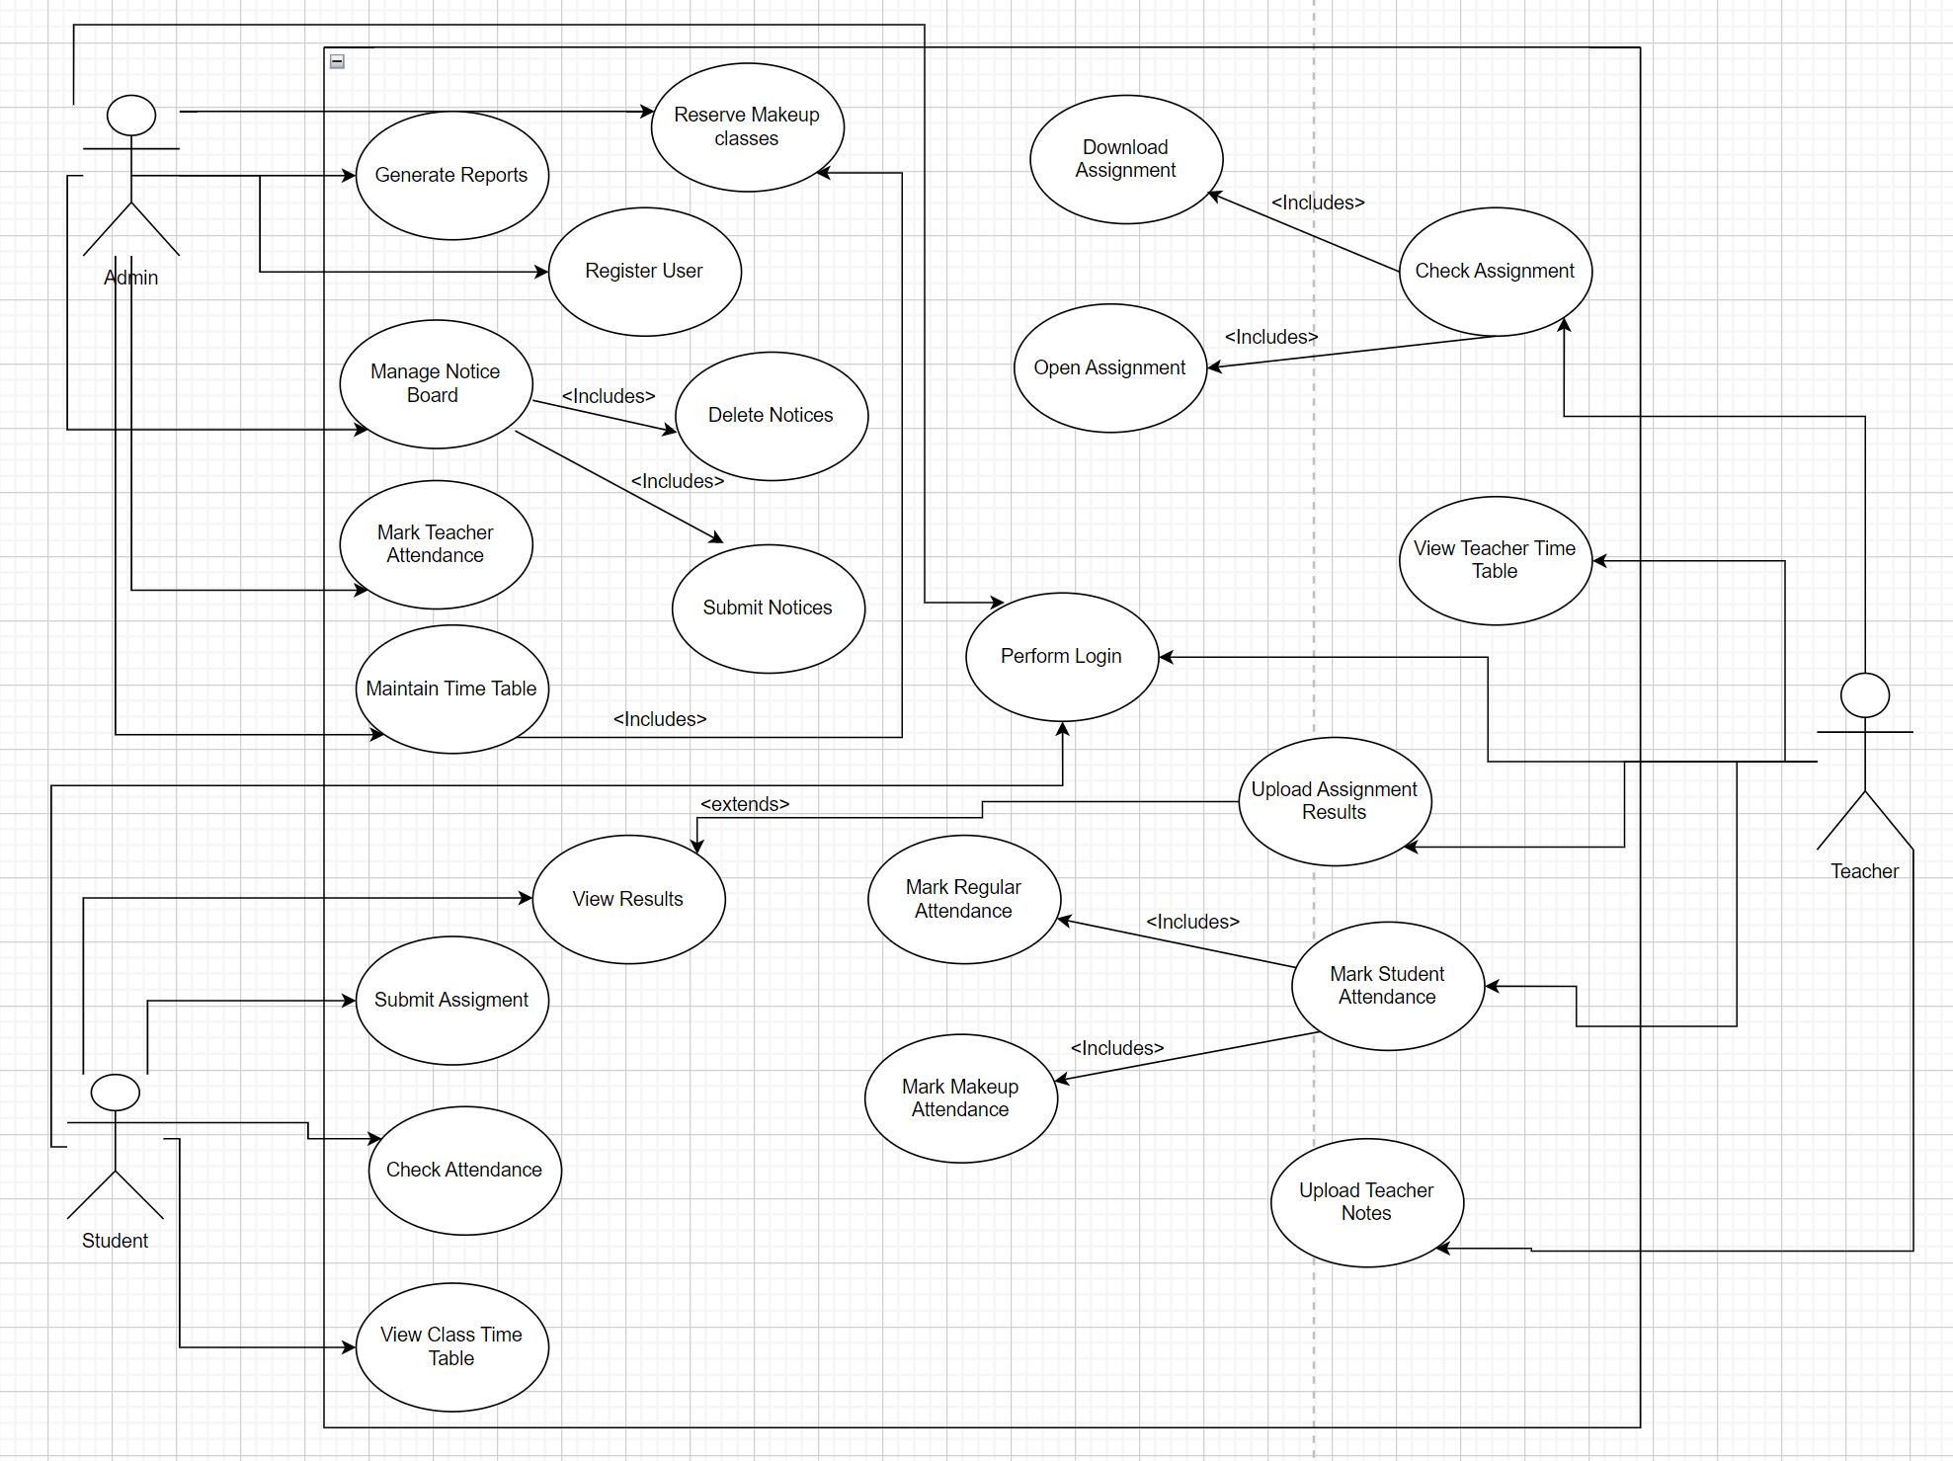

Domain Model
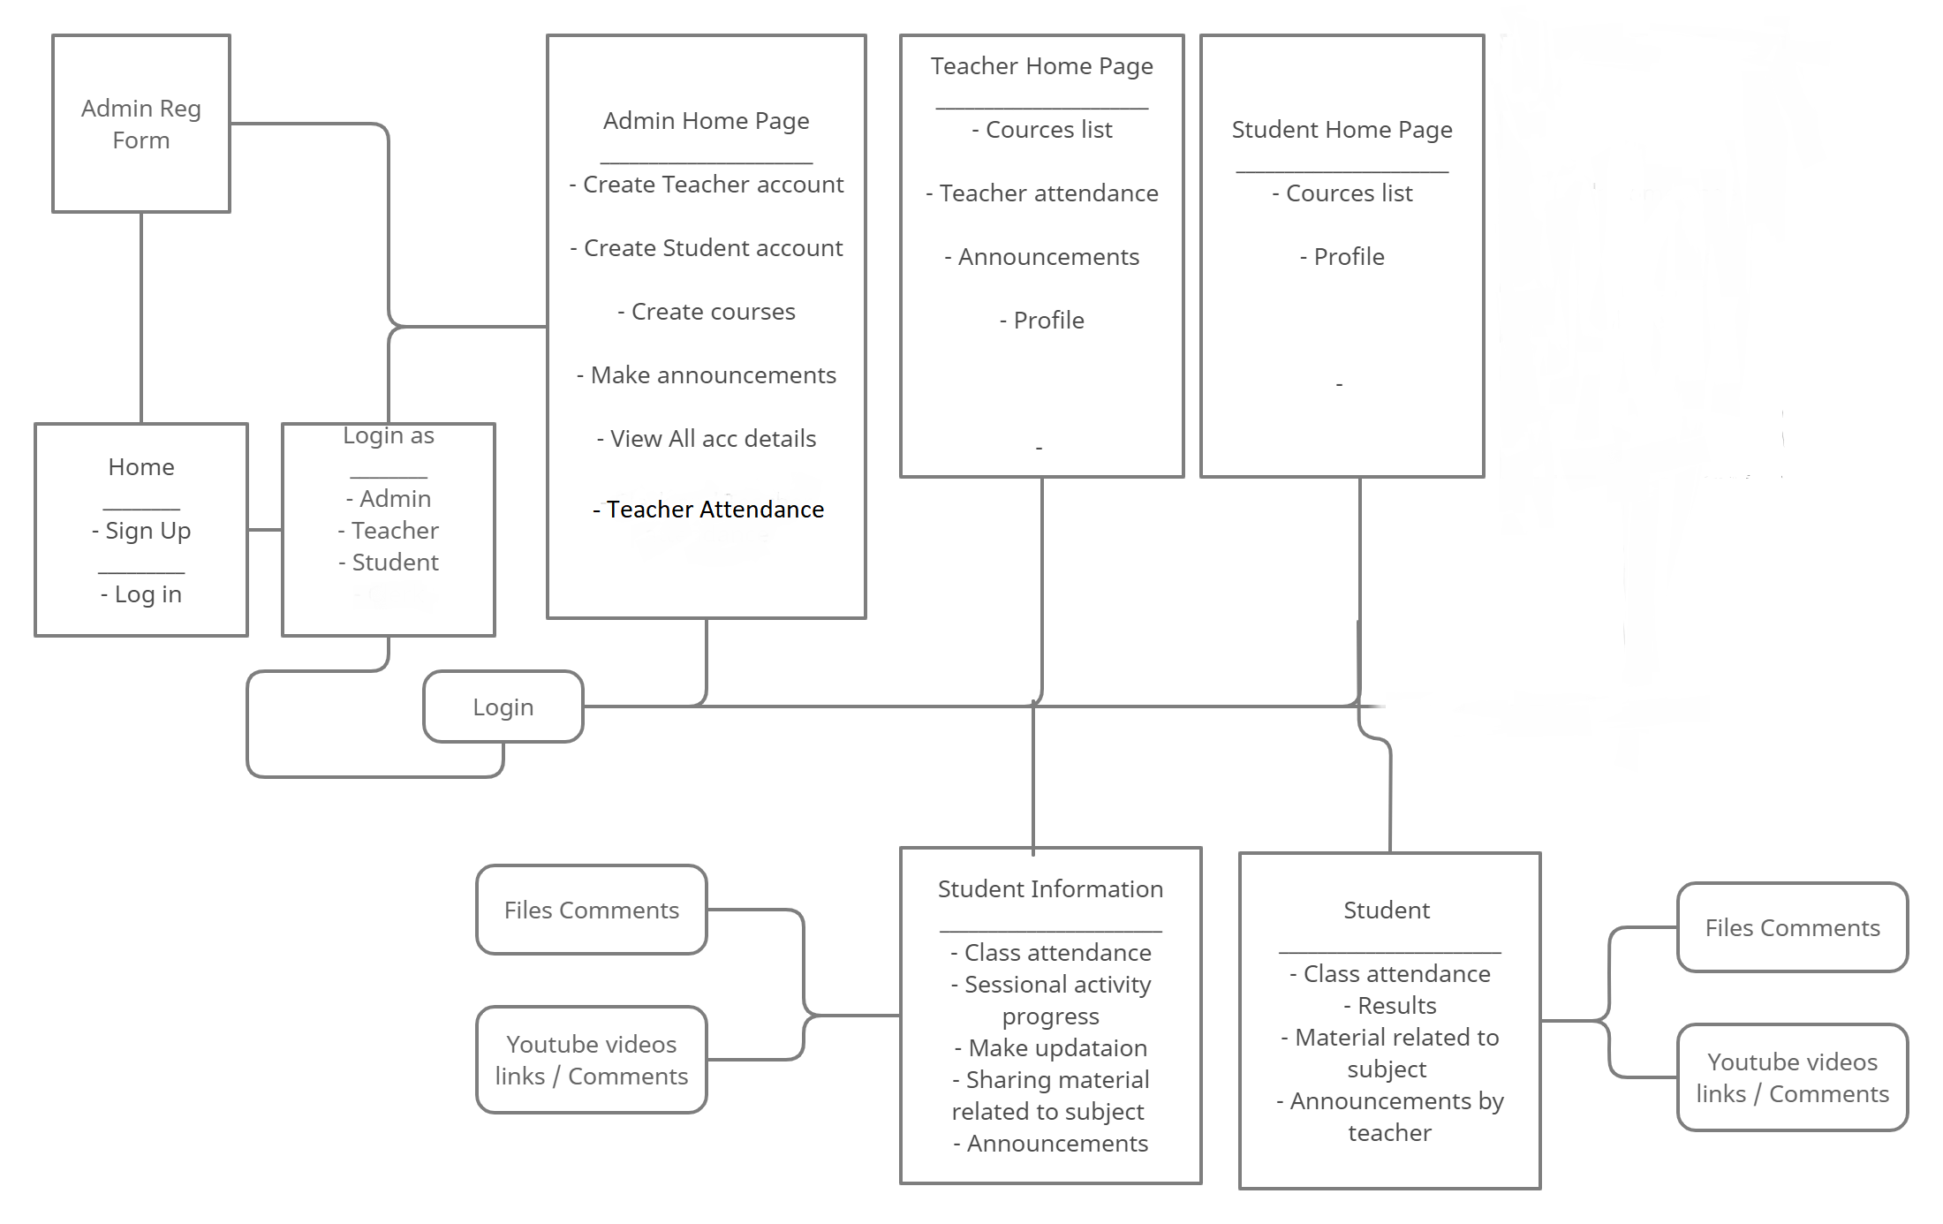

Collaboration Diagram

- Register User

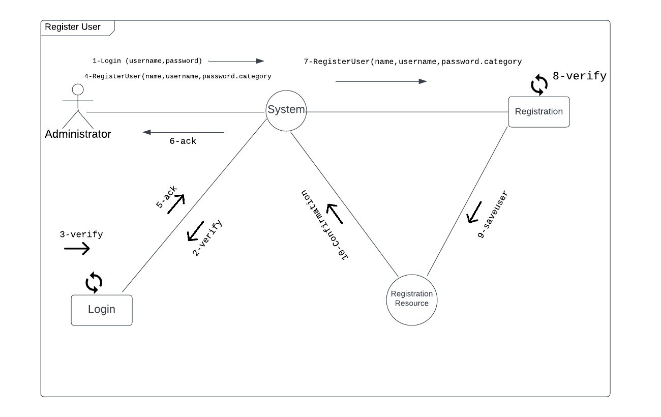

- Login:
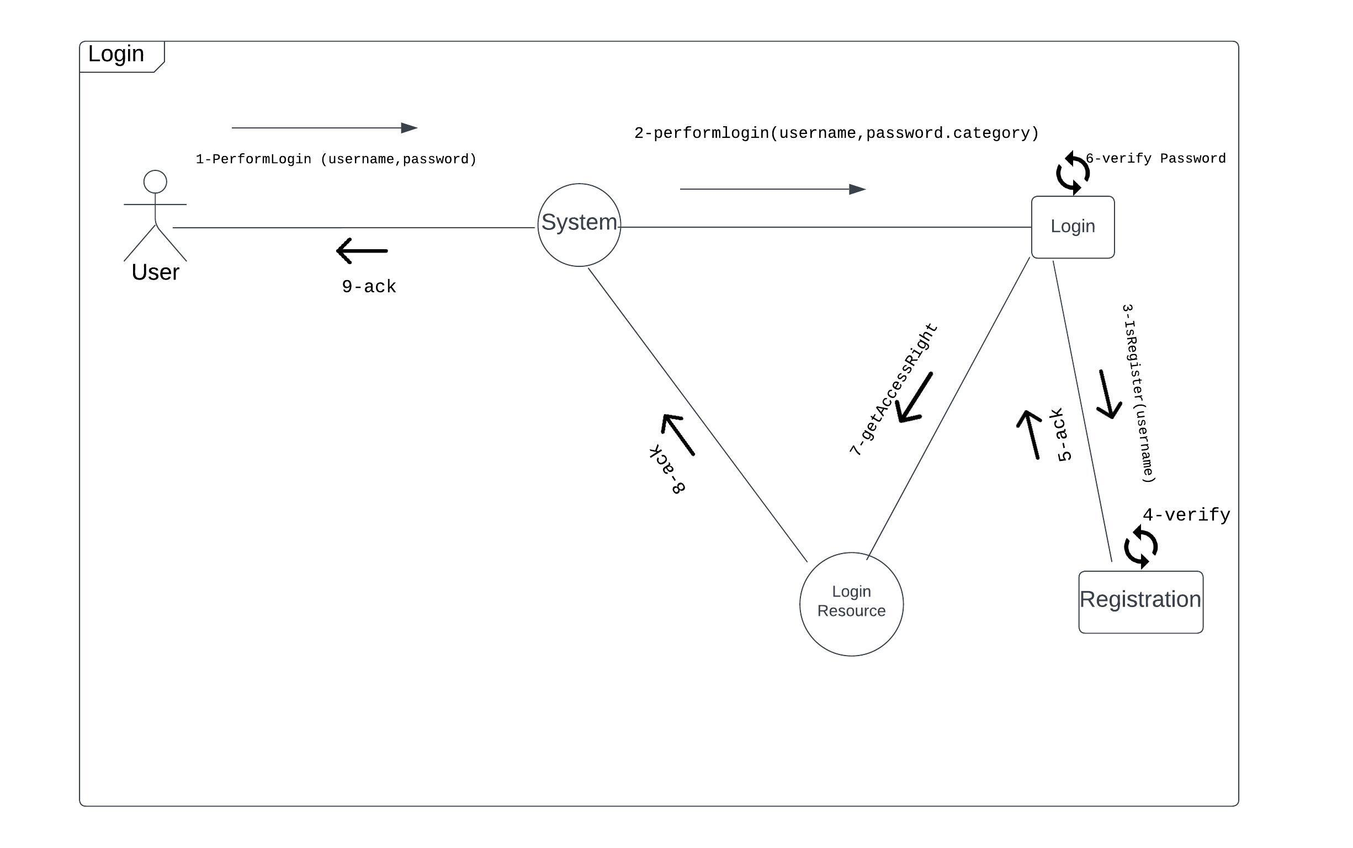

- Create Profile:
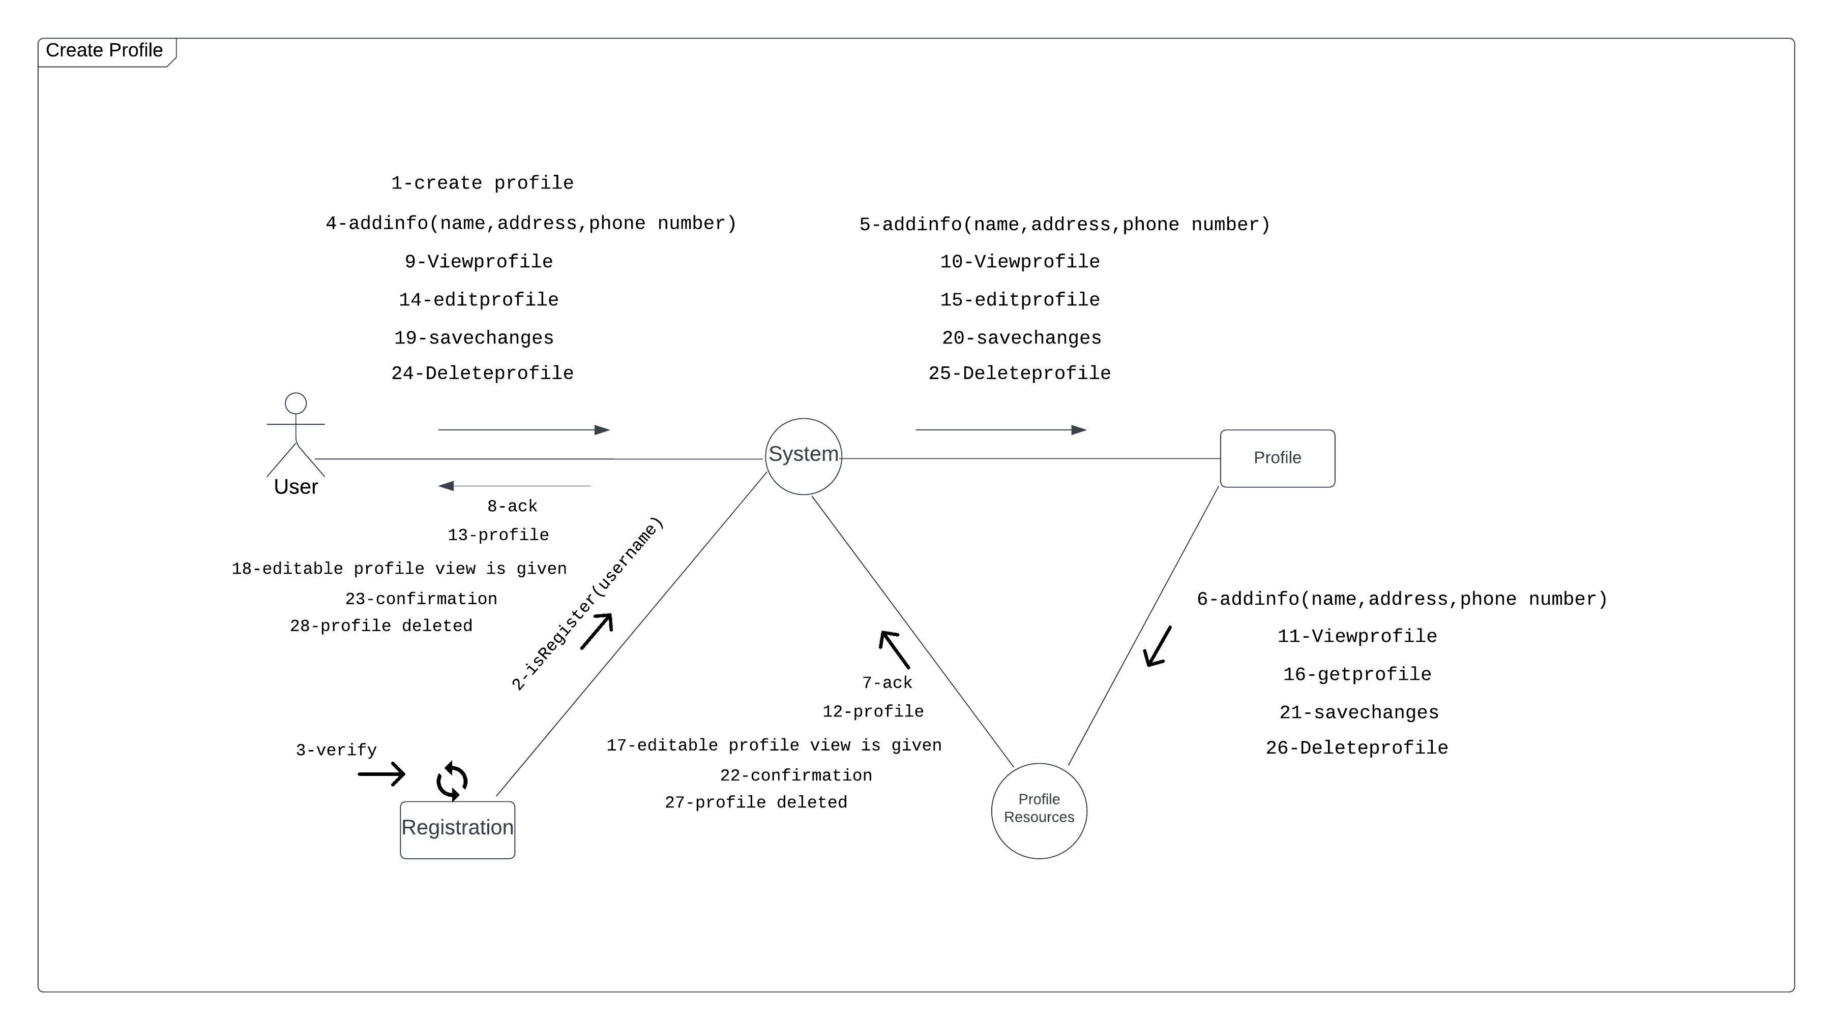

- Mark Student Attendance:
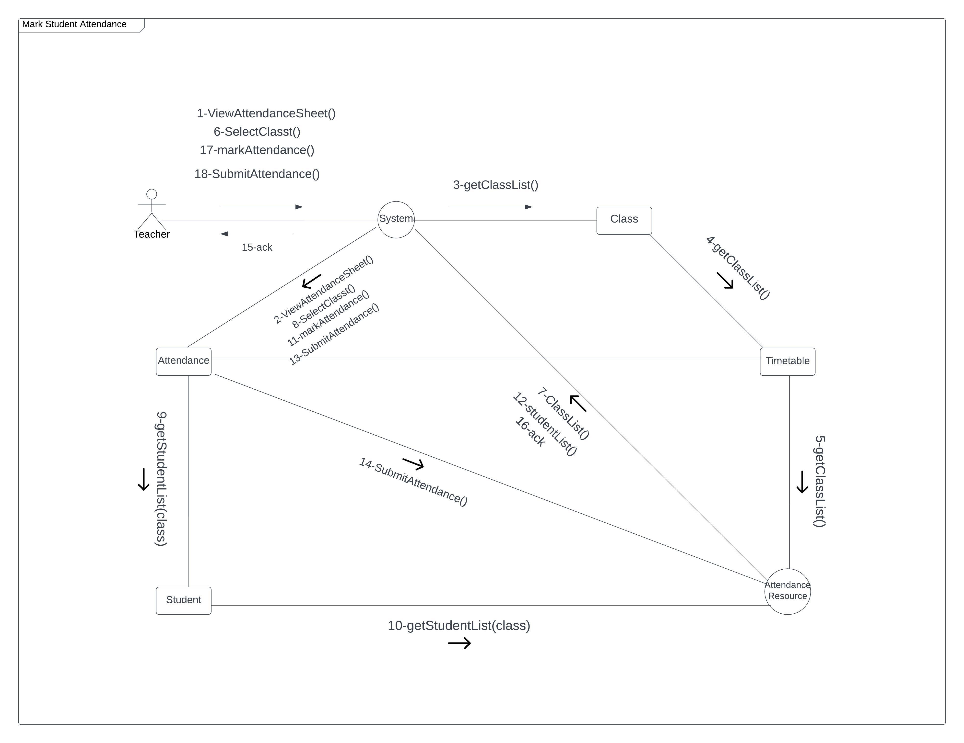

- View Profile 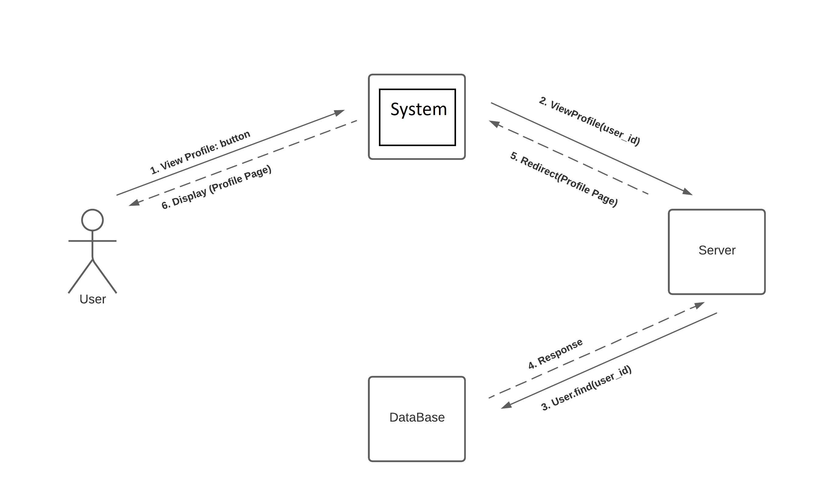
- Manage Notice Board:
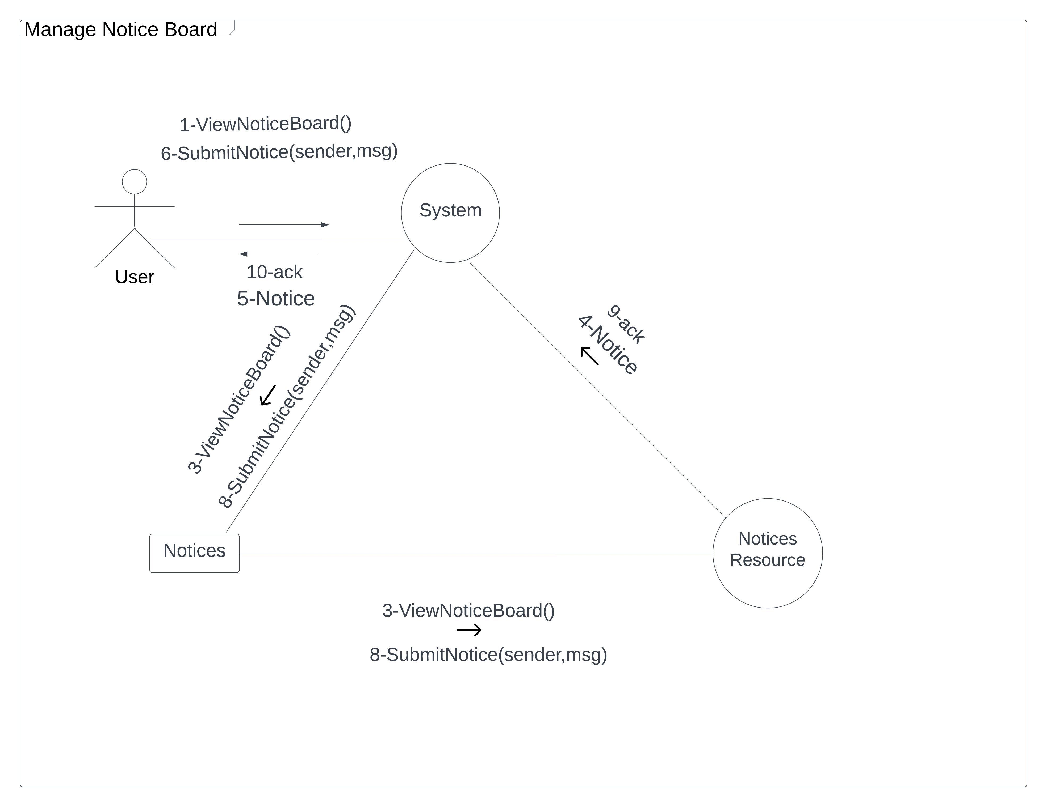
- Complete System Collaboration Diagram:
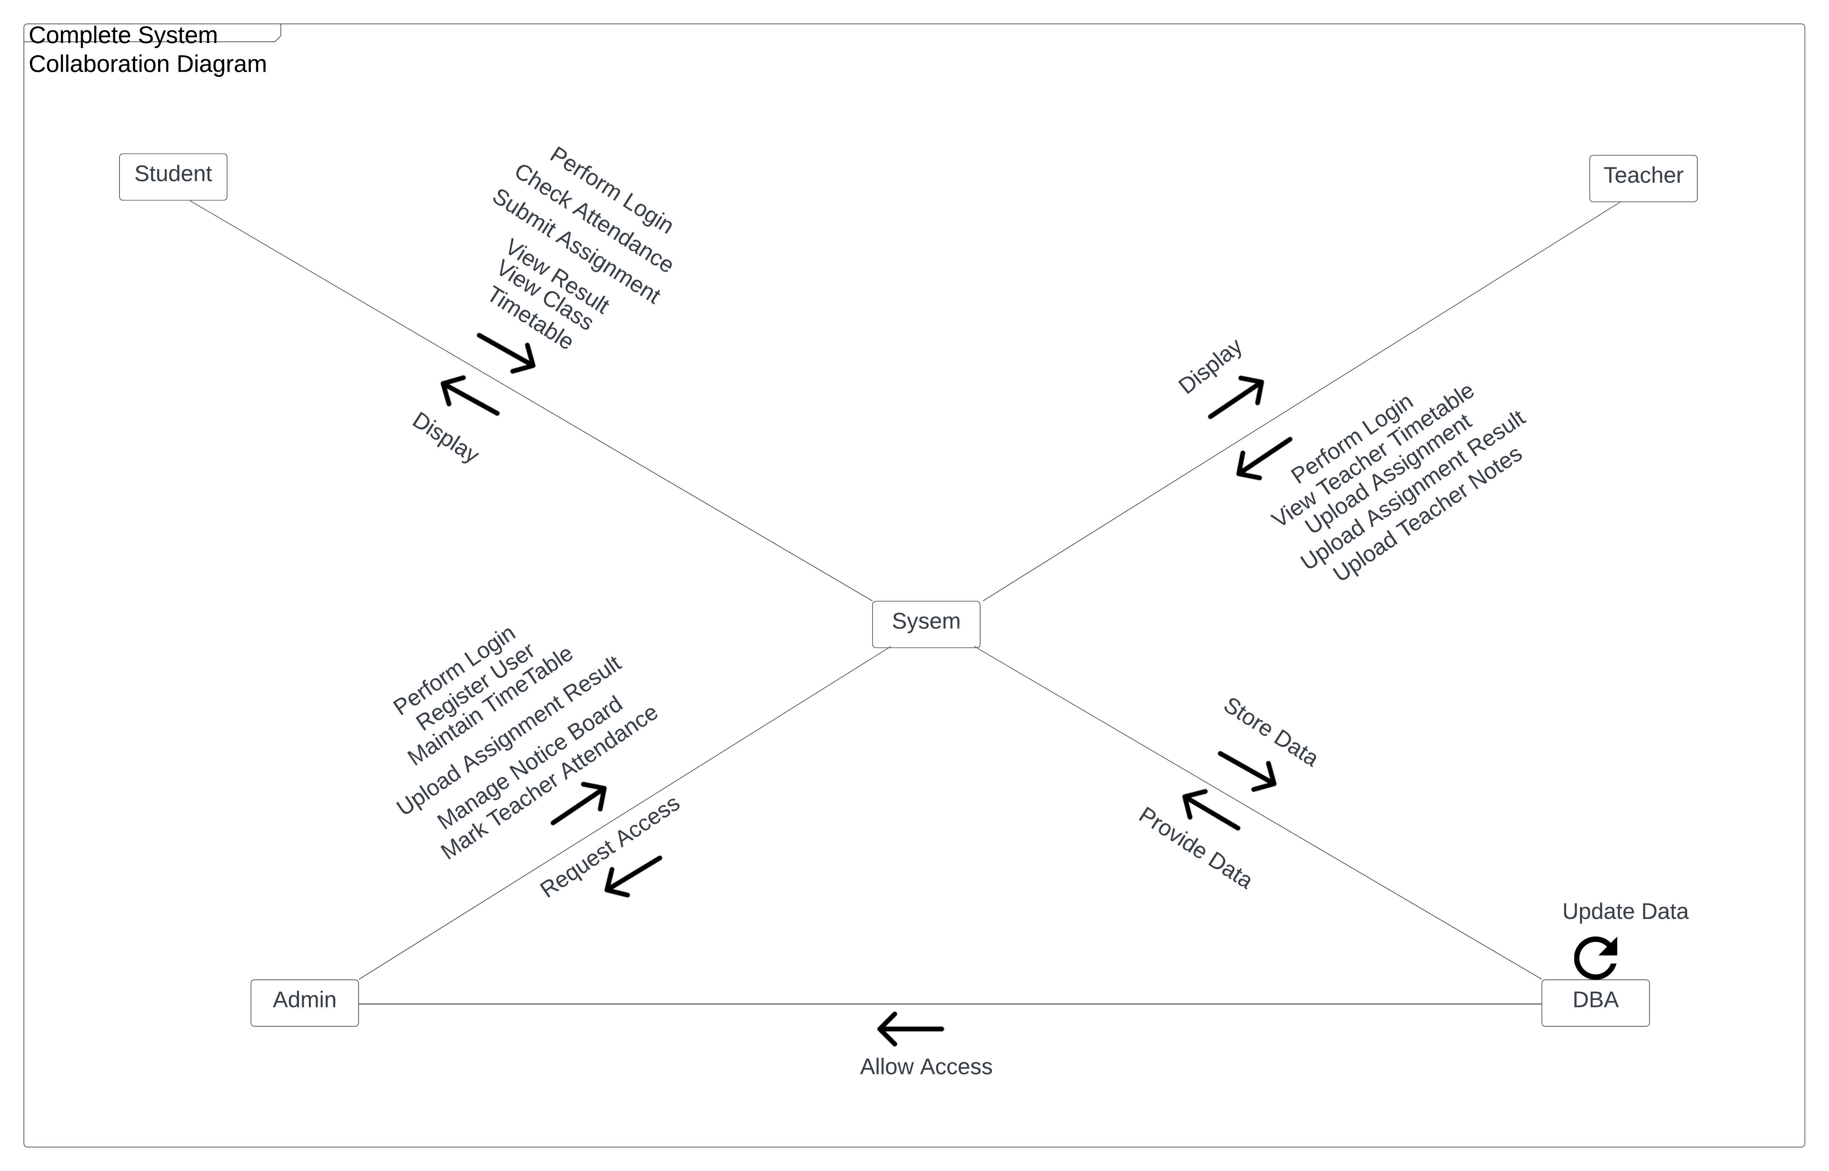

Operation Contracts

Operation Contract no: 1

Name:
Register User (name,email,password).
Responsibilities:
User admin has right to Sign up so that user can create a personal account on this website and avail various functionalities.

Cross Reference:
UC_Sign_Up

Exceptions:
- Internet is not available.
- User is already signed up and again trying to sign up.
- User provides invalid email.

Pre-Conditions:
- Website should be working properly without any failure.
- User must have a valid email before trying to sign up.

Post-Conditions:
- Instance of user model was created (instance creation).
- All Attributes of user model (name, email, password, reg_date) were initialized (attributes initialized).

Operation Contract no: 2

Name:
Login
Responsibilities:
User has right to Log in so that user can perform various functionalities on this website.

Cross Reference:
UC_Log_In

Exceptions:
- Internet is not available.
- User is not added to the system.
- User provides invalid email or password.

Pre-Conditions:
- Website should be working properly without any failure.
- User must have a valid email and password before trying to log in.

Post-Conditions:If user enters an incorrect email or password then a pop-up message is shown “Incorrect E-mail or Password”.

Operation Contract No: 3

Name:
Edit_Profile(As User Admin)
Responsibilities:
user admin to manage (editing and updating) of his/her/other user’s profile.

Cross Reference:
UC_Post_Ad

Exceptions:
- Internet is not available.
- User is not logged in.
Pre-Conditions:
- Website should be working properly without any failure.
- User must be logged in.
Post-Conditions:
- Instance of Ad model was created (instance creation).
- Instance of Ad model will be associated with instance of user and category. (association formed).

Operation Contract No: 4

Name:
Edit_Profile(As Main Admin)
Responsibilities:
User has right to Edit Ad so that user can update details of Ad.

Cross Reference:
UC_Edit_Ad

Exceptions:
- Internet is not available.
- User is not logged in.

Pre-Conditions:
- Website should be working properly without any failure.
- User must be logged in.

Post-Conditions:
- Attributes of instance of Ad model (title, desc, pics, loc, phone) were modified (attributes modification).

Operation Contract No: 5

Name:
View Notice Board
Responsibilities:
User has right to view Notice Board.

Cross Reference:
UC_View_Notice_Board

Exceptions:
- Internet is not available.
- User is not logged in.

Pre-Conditions:
- Website should be working properly without any failure.
- User must be logged in.

Post-Conditions:
- None.

Operation Contract No: 6

Name:
EditProfile(name, password, phone)

Responsibilities:
User has right to Edit Profile so that user can update details of profile.

Cross Reference:
UC_Edit_Profile

Exceptions:
- Internet is not available.
- User is not logged in.

Pre-Conditions:
- Website should be working properly without any failure.
- User must be logged in.

Post-Conditions:
- Attributes of instance of User model (name, password, phone) were modified (attributes modification).

Operation Contract No: 7

Name:
Delete_Account:
Responsibilities:
User has right to Send Request against a specific Ad for exchange.

Cross Reference:
UC_Send_Request

Exceptions:
- Internet is not available.
- User is not logged in.

Pre-Conditions:
- Website should be working properly without any failure.
- User must be logged in.

Post-Conditions:
- An instance of Request model will be created (instance creation).
- Instance of Request Model will be associated with instance of User Model and Ad Model (association formed).
- Attributes of instance of Request model (ad_id, requester_id, owner_id) were initialized (attributes initialization).

Operation Contract No: 8

Name:
Delete_Admin_Account:
Responsibilities:
User has right to Accept Request against a specific Ad for exchange.

Cross Reference:
UC_Accept_Request

Exceptions:
- Internet is not available.
- User is not logged in.

Pre-Conditions:
- Website should be working properly without any failure.
- User must be logged in.

Post-Conditions:
- Attribute of instance of Request model (status) was modified (attributes modification).

Operation Contract No: 9

Name:
Give_Privilege:
Responsibilities:
User has right to Chat against a specific Ad in which he is interested in.

Cross Reference:
UC_Chat

Exceptions:
- Internet is not available.
- User is not logged in.

Pre-Conditions:
- Website should be working properly without any failure.
- User must be logged in.

Post-Conditions:
- Instance of Chat Model was created (instance creation).
- Attributes of Chat Model were initialized (attributes initialization).
- Instance of Chat Model was associated with instance of User Model and Ad Model (association formed).

Operation Contract No: 10

Name:
Feedback
Responsibilities:
User has right to Report an Ad that user finds inappropriate.

Cross Reference:
UC_Report_Ad

Exceptions:
- Internet is not available.
- User is not logged in.

Pre-Conditions:
- Website should be working properly without any failure.
- User must be logged in.

Post-Conditions:
- Instance of Report Model was created (instance creation).
- Attributes of instance of Report Model were initialized (attributes initialization).
- Instance of Report Model was associated with instance of User Model , Ad Model and Admin Model (association formed).

Operation Contract No: 11

Name:
Log_Out
Responsibilities:
It allows admin to add a new category in category list.

Cross Reference:
UC_Add_Category

Exceptions:
- Internet is not available.
- Admin is not logged in.

Pre-Conditions:
- Website should be working properly without any failure.
- Admin must be logged in.

Post-Conditions:
- Instance of Category Model was created (instance creation).
- Attributes of Category Model were initialized (attributes initialization).
- Instance of Category Model was associated with instance of Admin Model (association formed).

Operation Contract No: 12

Name:
ViewReport(id)
Responsibilities:
It allows admin to view a report about an Ad.

Cross Reference:
UC_View_Report

Exceptions:
- Internet is not available.
- Admin is not logged in.

Pre-Conditions:
- Website should be working properly without any failure.
- Admin must be logged in.

Post-Conditions:
- None.

1.7 Design Class Diagram

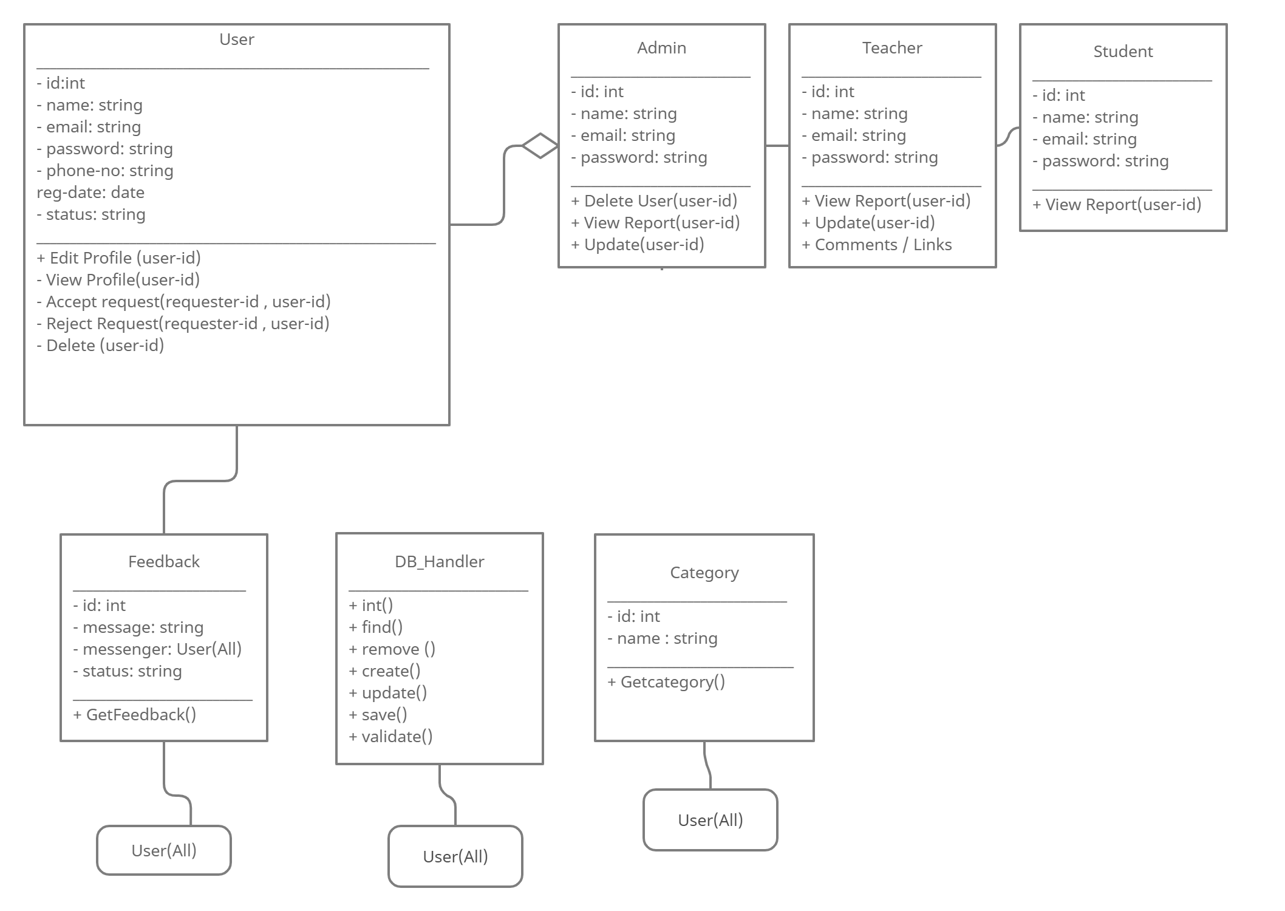

END!

